EROS | Metallic | Roughness | Specular IOR level | Flux range
1 | 0 | 0 | 0.5 | Relative flux range: 0.5958755507010907 - 1.3697106672825259
2 | 0 | 0.25 | 0.5 | Relative flux range: 0.590032674607708 - 1.4019010174486541
3 | 0 | 0.5 | 0.5 | Relative flux range: 0.5846289189600834 - 1.4150849960413698
4 | 0 | 0.75 | 0.5 | Relative flux range: 0.5871983168790571 - 1.3775932193183253
5 | 0 | 1 | 0.5 | Relative flux range: 0.5989825242817552 - 1.361772782277629

1)Roughness analisys 25/5/2023

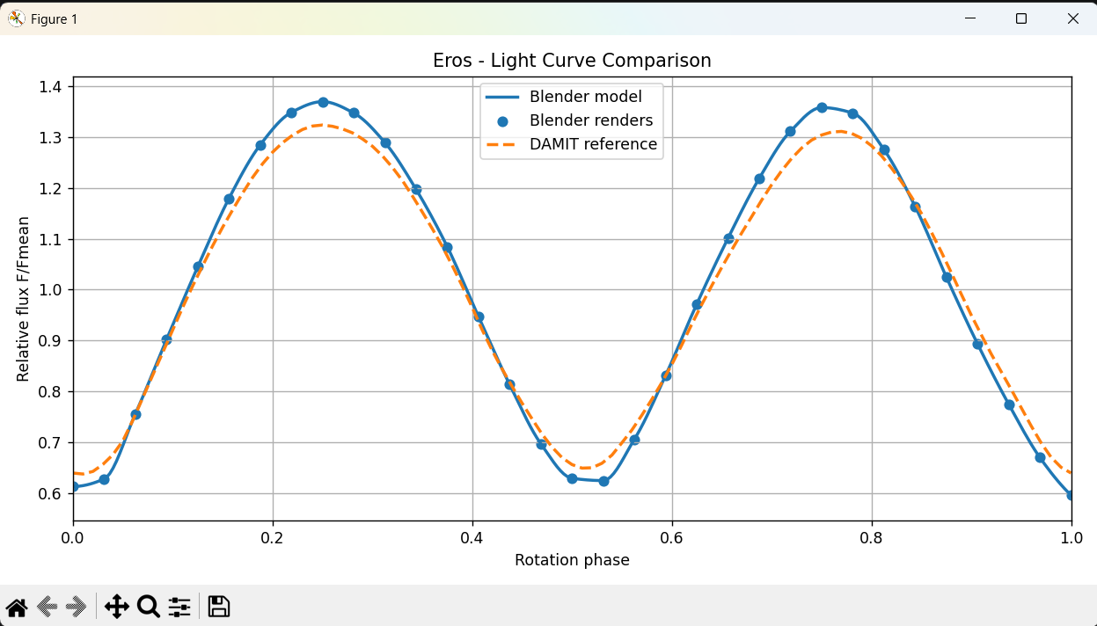
Figura 1
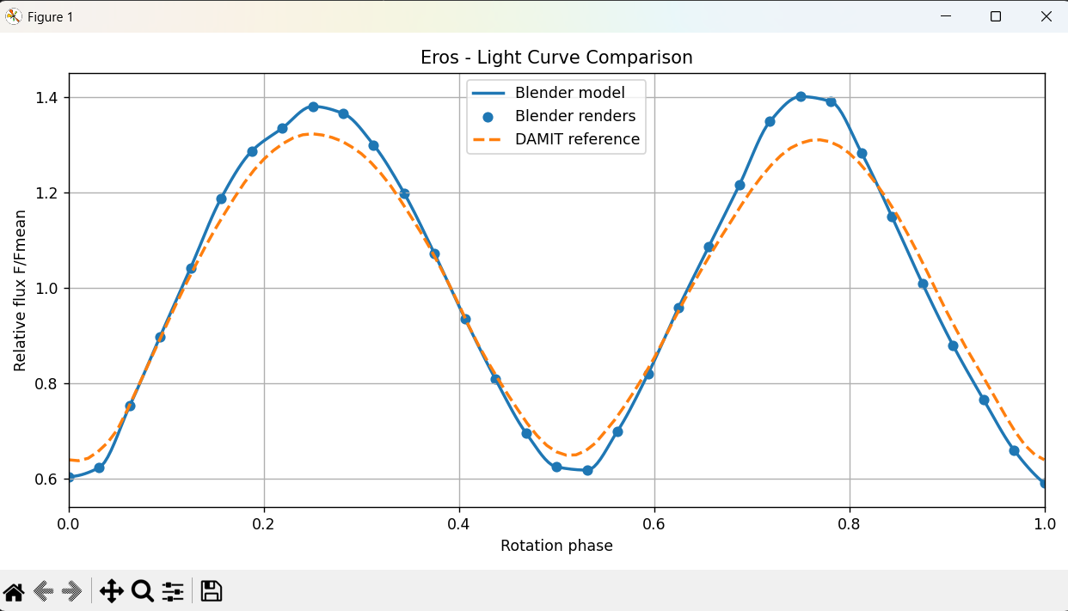
Figura 2
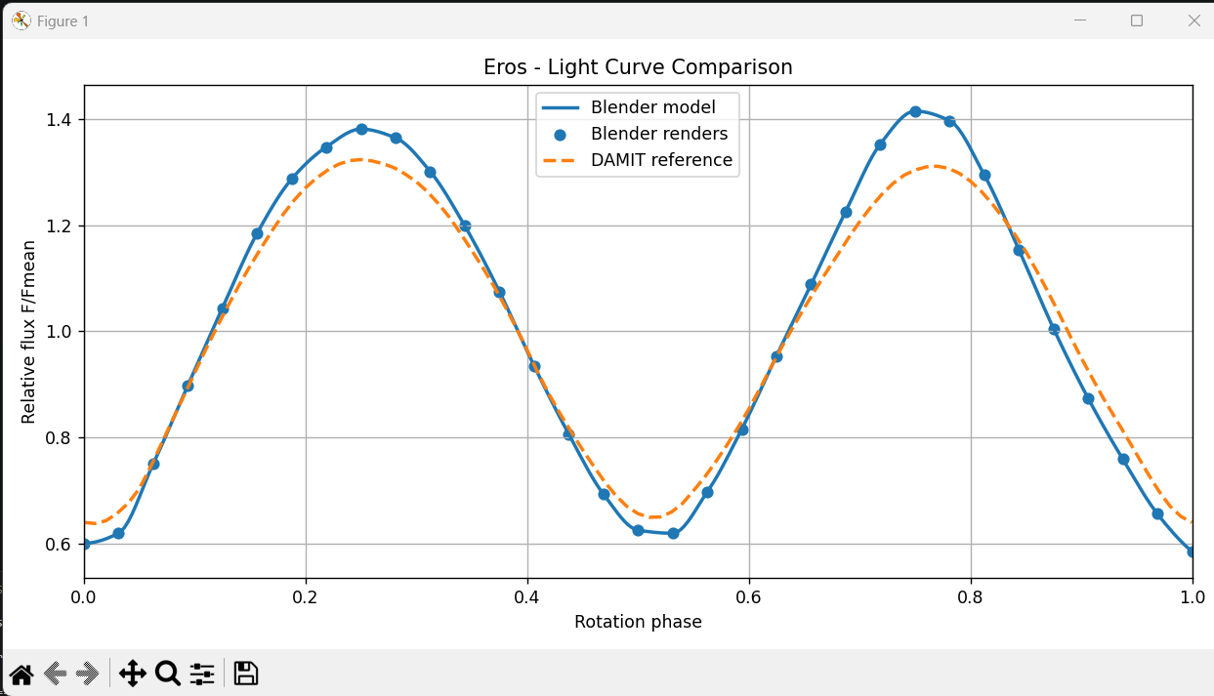
Figura 3
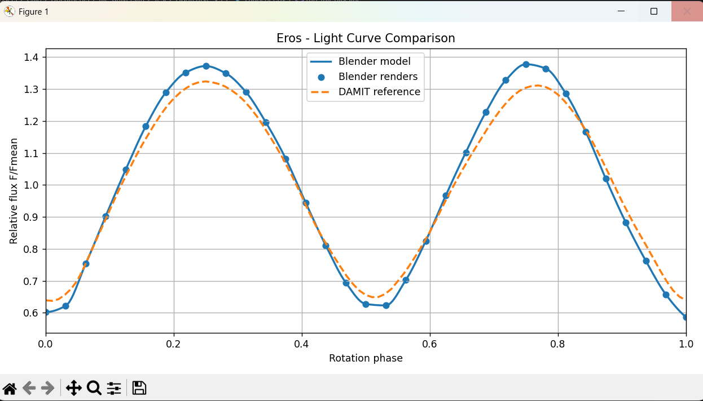
Figura 4
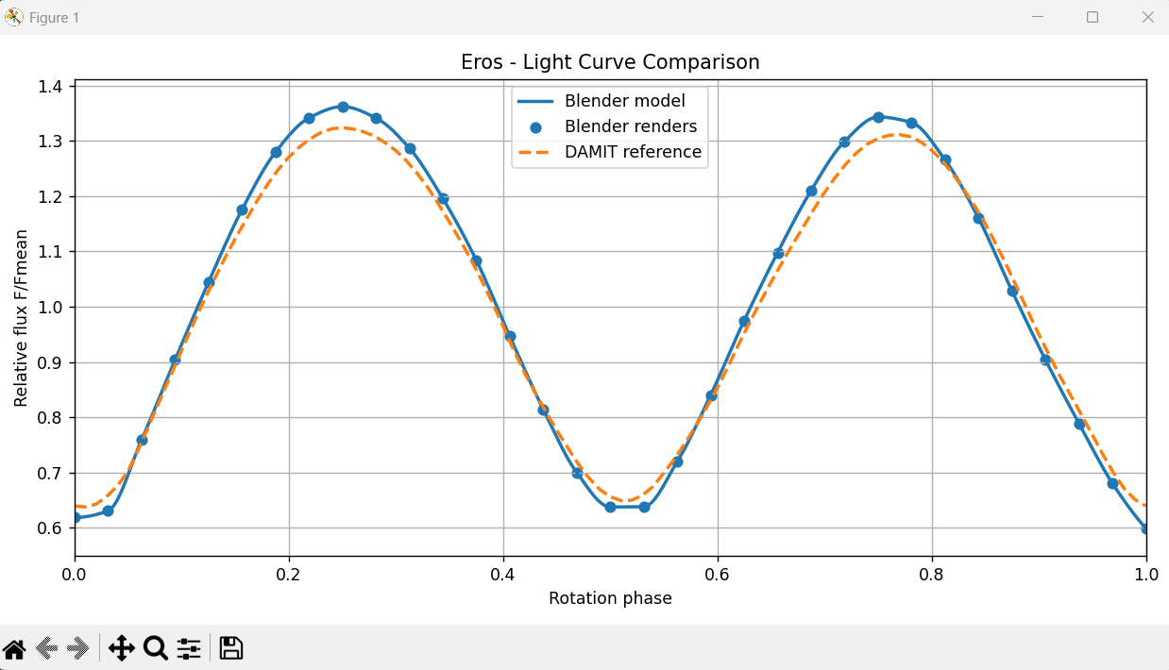
Figura 5

Metallic analisys
EROS | Metallic | Roughness | Specular IOR level | Flux range
6 | 0 | 0.85** | 0.5 | Relative flux range: 0.5901137506305066 - 1.3689347864717833
7 | 0.25 | 0.85** | 0.5 | Relative flux range: 0.5812563431734123 - 1.3770221889577714
8 | 0.5 | 0.85** | 0.5 | Relative flux range: 0.5676834087002003 - 1.4001091995401649
9 | 0.75 | 0.85** | 0.5 | Relative flux range: 0.5437257410792925 - 1.4384470614790843
10 | 1 | 0.85** | 0.5 | Relative flux range: 0.460413738877674 - 1.5254538489863856

** averange value for rocky asteroids
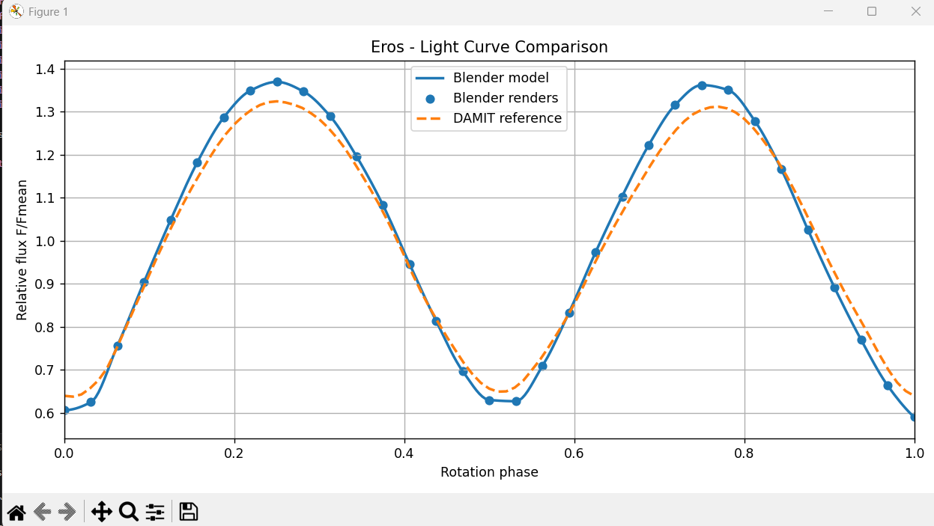
Figura 6
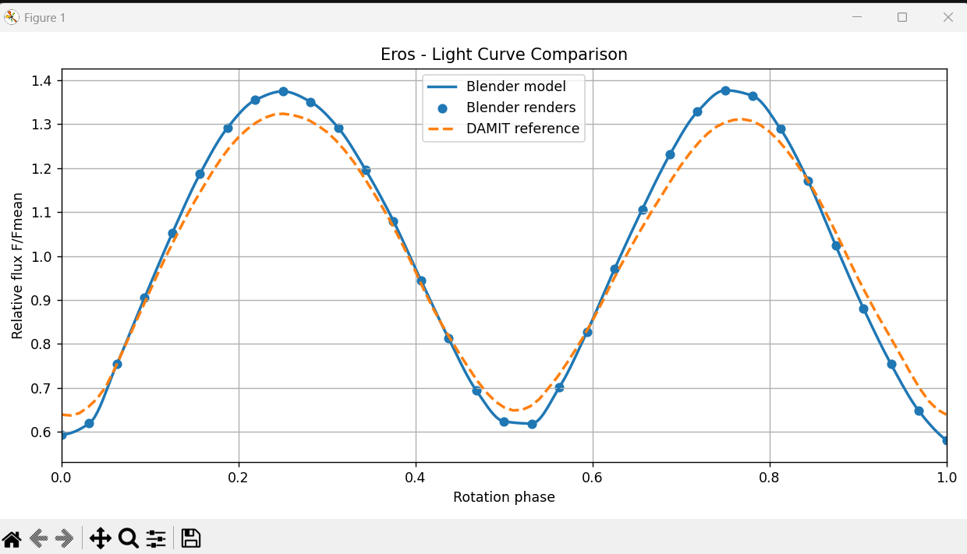
Figura 7
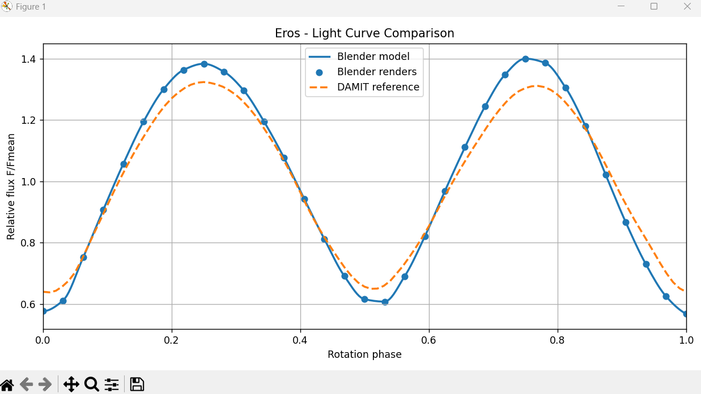
Figura 8
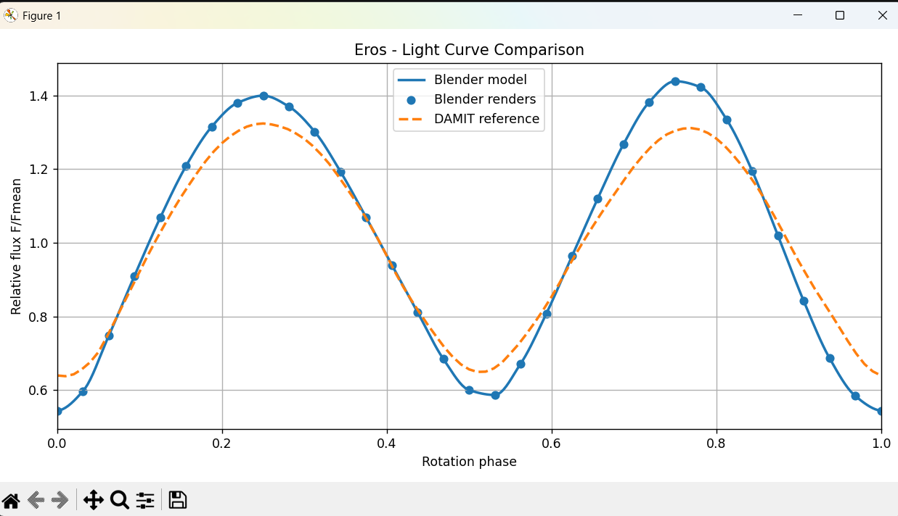
Figura 9
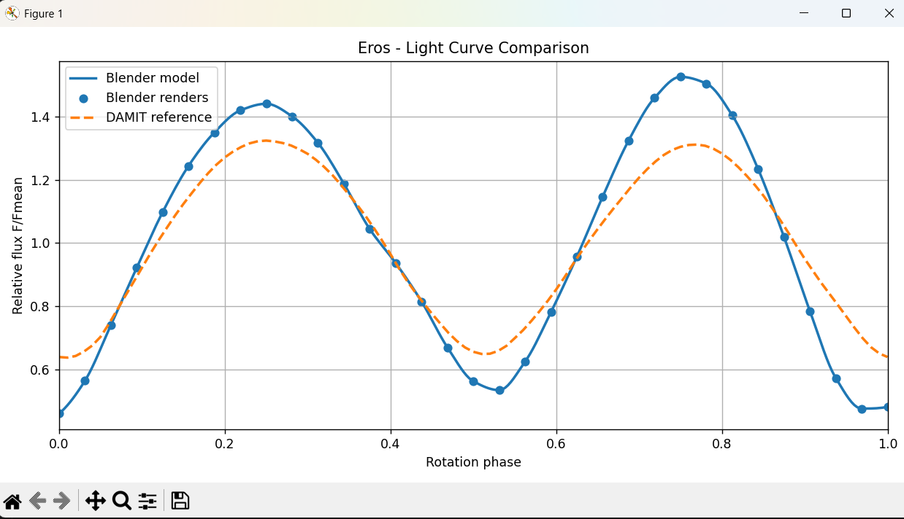
Figura 10
These results make sense, as setting Metallic = 0 in Blender correctly defines the material as a dielectric, enabling the diffuse reflection behaviour characteristic of asteroidal rock.

Specular IOR
EROS | Metallic | Roughness | Specular IOR level | Flux range
11 | 0** | 0.85** | 0.0 | Relative flux range: 0.5952263475691391 - 1.3658363058206549
12 | 0** | 0.85** | 0.5 | Relative flux range: 0.5901137506305066 - 1.3689347864717833
13 | 0** | 0.85** | 1 | Relative flux range: 0.5853327007093846 - 1.3720898441634635

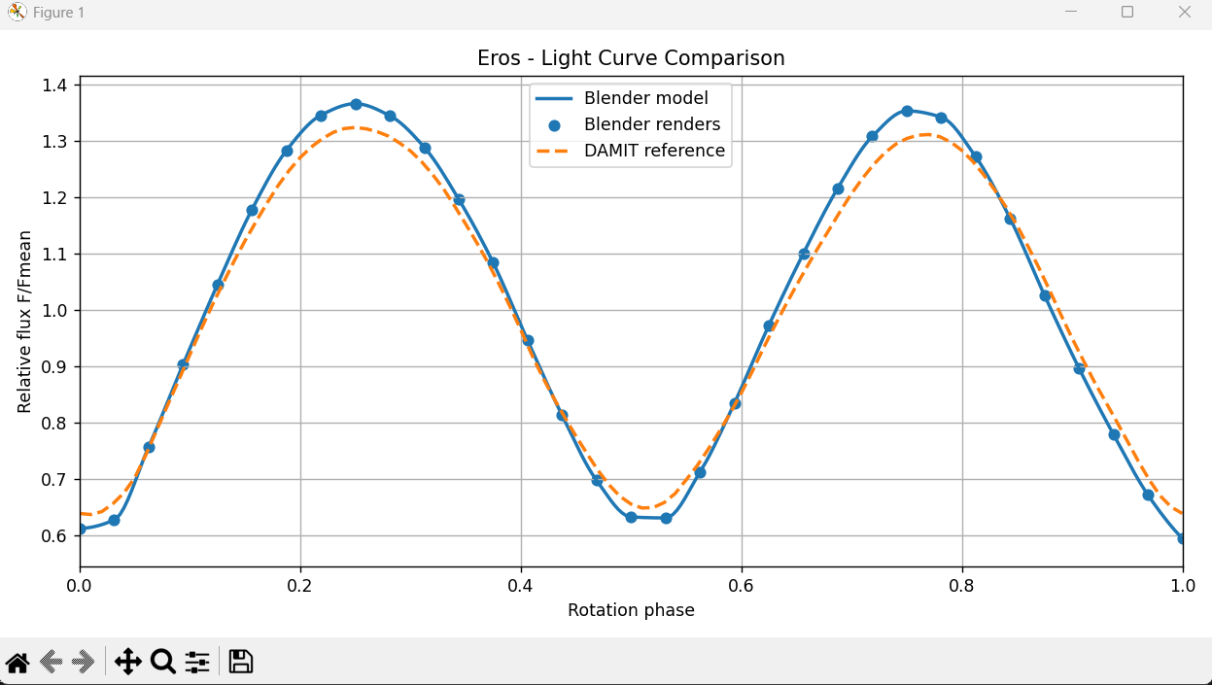
Figura 11
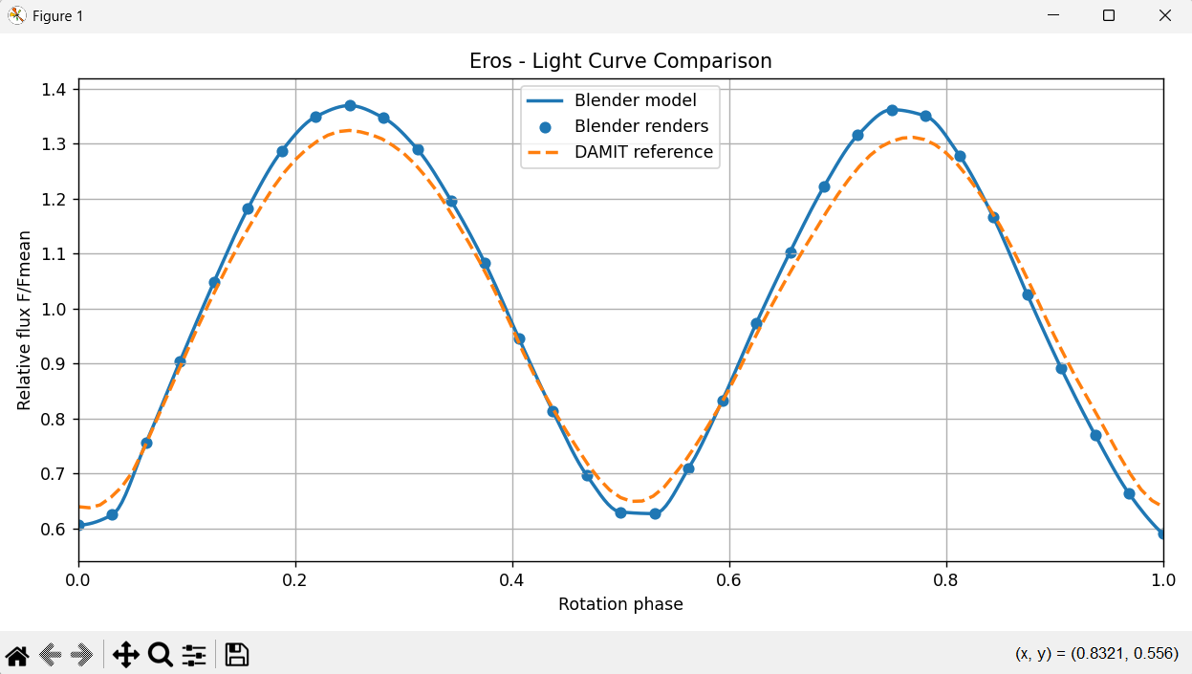
Figura 12
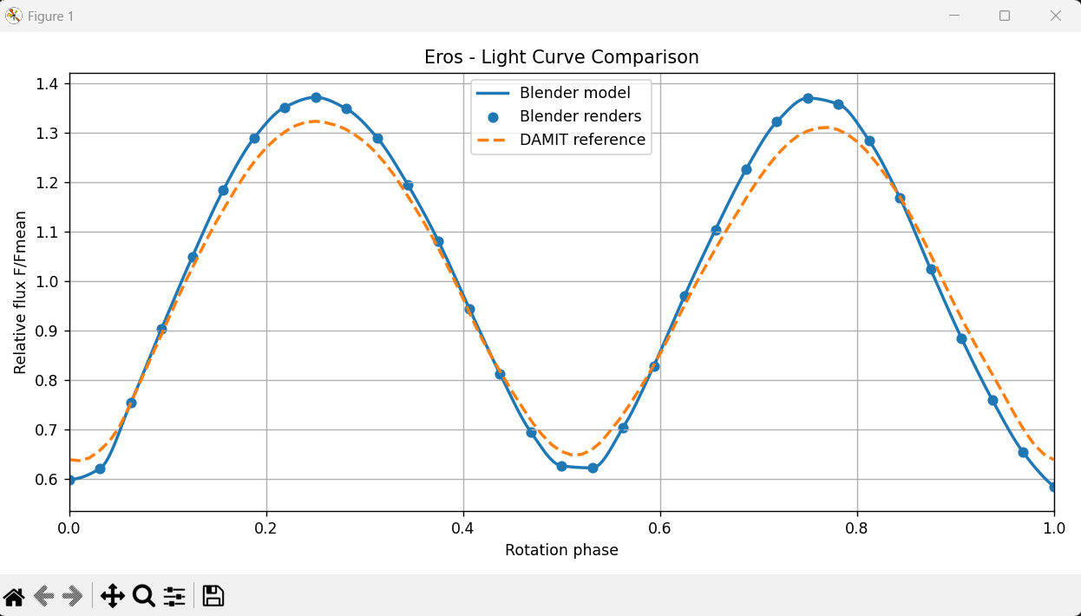
Figura 13

In Blender, the Specular IOR Level represents the index of refraction (IOR) of the material, controlling how strongly light is specularly reflected from the surface. A value of 0.5 works well because it corresponds to an IOR of around 1.5, which is typical for silicate rocks and asteroidal regolith.

Data fit Problematic 09/08/2026 Eros
bsdf.inputs["Base Color"].default_value = (0.18, 0.18, 0.18, 1)
bsdf.inputs["Metallic"].default_value = 0
bsdf.inputs["Roughness"].default_value = 0.85
bsdf.inputs["Specular IOR Level"].default_value = 0.5
links.new(bsdf.outputs["BSDF"], out.inputs["Surface"])

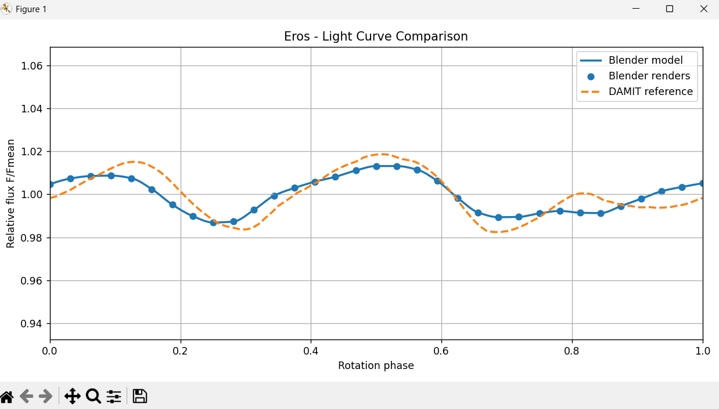

bsdf.inputs["Base Color"].default_value = (0.18, 0.18, 0.18, 1)
bsdf.inputs["Metallic"].default_value = 0
bsdf.inputs["Roughness"].default_value = 0.70
bsdf.inputs["Specular IOR Level"].default_value = 0.5
links.new(bsdf.outputs["BSDF"], out.inputs["Surface"])
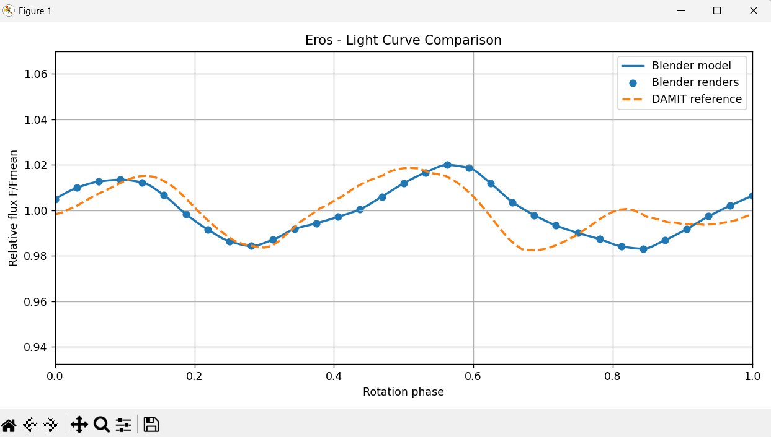

bsdf.inputs["Base Color"].default_value = (0.18, 0.18, 0.18, 1)
bsdf.inputs["Metallic"].default_value = 0.5
bsdf.inputs["Roughness"].default_value = 0.85
bsdf.inputs["Specular IOR Level"].default_value = 0.5
links.new(bsdf.outputs["BSDF"], out.inputs["Surface"])
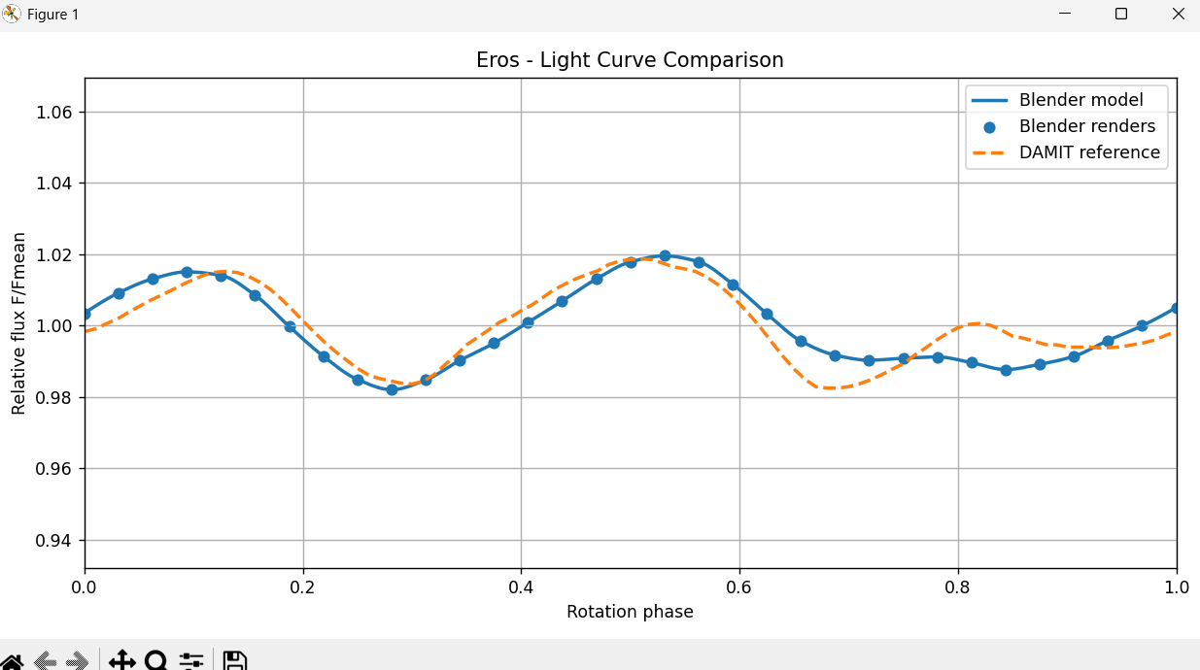

Data fit Problematic 18/08/2026 Eros
bsdf.inputs["Base Color"].default_value = (0.18, 0.18, 0.18, 1)
bsdf.inputs["Metallic"].default_value = 0.0
bsdf.inputs["Roughness"].default_value = 0.85
bsdf.inputs["Specular IOR Level"].default_value = 0.5
links.new(bsdf.outputs["BSDF"], out.inputs["Surface"])
